**TABLE OF CONTENTS**

1. **Abstract 1**
2. **Introduction 1**
3. **Objective 1**
4. **Scope 2**
5. **Technologies used 2**
6. **Benefits 2**
7. **Limitations 2**
8. **Architecture View 2**
9. **Architecture Diagram 3**
10. **Working of the Website 3**
11. **Flow chart 4**
12. **Screenshots of the website 5**
13. **Conclusion 14**
14. **Future 14**
15. **For Reference 14**

**Abstract**:

In today's busy and expensive life we are in a great rush to make money, but at the end of the month we broke off. As we are unknowingly spending money on little and unwanted things. So ,we have to come up with the idea to track our earnings . Money Manager aims to help Call everyone who are planning to know their expenses and save from it.It is a web application which has dashboard in which users can do manual entry of their expenditure,update their daily expenses at any time they want ,so that they are well known to the expenses.User will be able to see pie chart of expenses and they can view their expenses report according to date wise,month wise and year wise. Although this app is focused on new job holders and teenagers,everyone who wants to track their expenses can use this web application.

The web application “Money Manager” is developed to manage the daily expenses in a more efficient and manageable way. By using this application we can reduce the manual calculations of the daily expenses and keep track of the expenditure. In this application, the user can provide their income , target savings and target period for savings, to manage their total expenses and save money according to it. and these details will be stored for each user. In the result it will check your bank balance and display “ You have reached your goal” if the user achieved the target savings or “You need to have a cap on the expenditure” if the user didn’t achieve their target savings . In this application, there is a login for users. Users have the privilege to add, edit and to get all custom reports.

**Introduction :**

Tracking daily expenses is not so innovative. Many traditional and technological approaches found how to track our expenses and budget with their own functionality. From decades ago and today we have been writing our expenditure in a register to calculate the profit or saving. Not only this Mini desktop and mobile applications have been developed for this purpose. Quicken and Microsoft money were the first desktop applications developed decades ago but were not so familiar with the users.

Money Manager is a refined system which allows the user to efficiently manage their expenses with ease.Tracking expenses daily can really help to save a lot of money. Once they start off by tracking their expenses each day, they will be able to get a better idea where they are spending their money, so they can stay in control and achieve their goal.This website will be able to generate their expenses and saving reports as time duration they selected.

**Objective:**

* To keep track of daily expenses and budgeting.
* Users don't need to calculate on their own and they don't need to have a manual budget plan.

**Scope:**

* This application can have a good market as it is usable by anyone who is willing to manage their expenses and aims to save for future investments and many more.
* There is no any range criteria or any kind of profession or gender that is focused, that this website will be used hugely.

**Technologies used:**

**FRONT END**

* HTML
* CSS
* Java Script
* PHP
* JSON

**BACKEND:**

* MySQL

**DATABASE:**

* Phpmyadmin

**CODING PLATFORM:**

* Visual Studio

**Benefits:**

* Users can track their Expenditure .
* Users can set a target savings and target period for efficient savings.

**Limitation:**

* Users have to record cash expenditure manually.

**Architecture View:**

Front end is used to collect data and display the results.In the Frontend , for Designing the page we used HTML, CSS and the functions of the working page we used JavaScript, PHP, JSON.Backend is used to store the data which we collected from the users.In the Backend we used MySQL Database to store the datas.We used the platform Phpmyadmin for database storage and Visual studio for coding purpose.

**Architecture Diagram:**

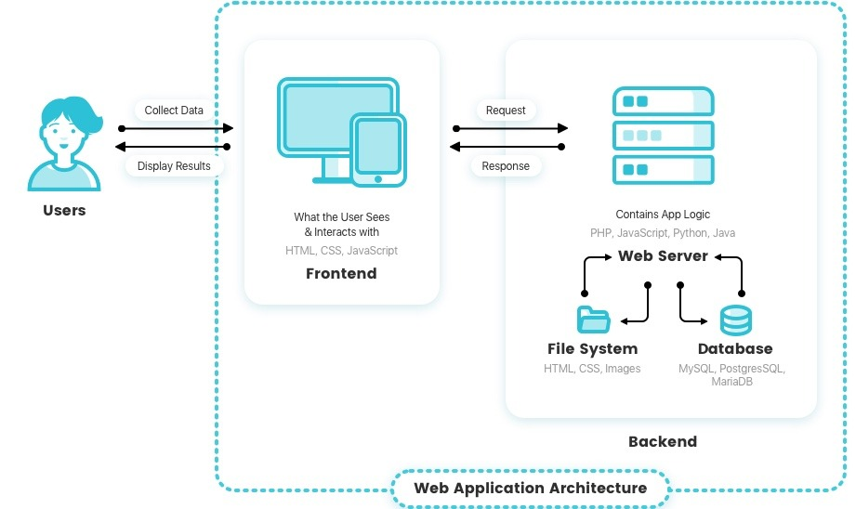

**Working of the Website:**

First Users enter into the website by login if they registered before.If they are a new user then they have to register to the website by signing up.If the users forgets their Password there is an option for forget password in which they can reset their password by entering their email.After login it will go to the Dashboard where many options like Expense, Expense Report, Information, Logout.In the Expense we have two options Add Expense, Manage Expense.Add Expense user can add their daily expenses manually by entering the Date,the Item and the Cost of the Item, when the user clicks submit button the expenses are added successfully.In Manage Expense user can see their expenses which they entered.They can also Delete the expenses which they entered wrong.In Expense Report we have three options Date Wise Report, Month Wise Report, Year Wise Report.

In Date Wise Report user can enter the date in which they want to see their expenses.Month Wise Report User can enter the month in which they want to see their expenses.Year Wise Report User can enter the year in which they want to see their expenses.In Information user enters the details like their income, how much they want to save,the target period etc .The backend will check to the database of the user’s Bank Balance ,if the balance is less than the target savings it will displays “You need to have a cap on your Expenditure” and if the balance is greater than the target savings it will display “You Reached your Goal”.We also have Transaction History in which user can see their Bank Transactions details.After using our website user clicks Logout button which logs out of the website.

**Flow chart :**

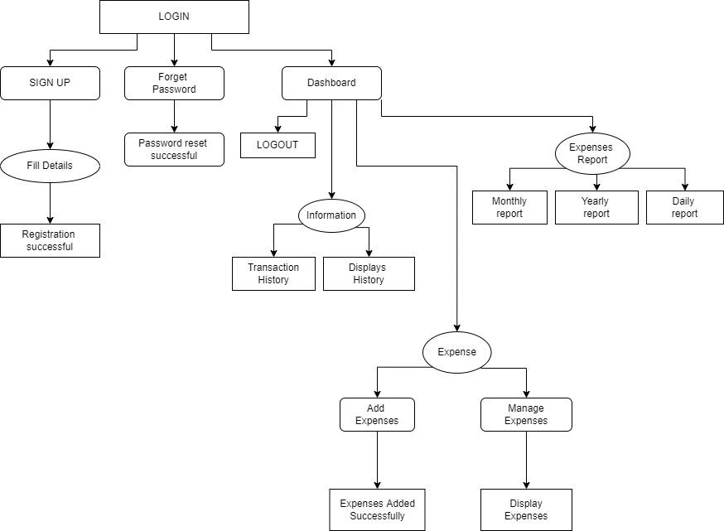

**Screenshots of the website :**

**Home Page:**

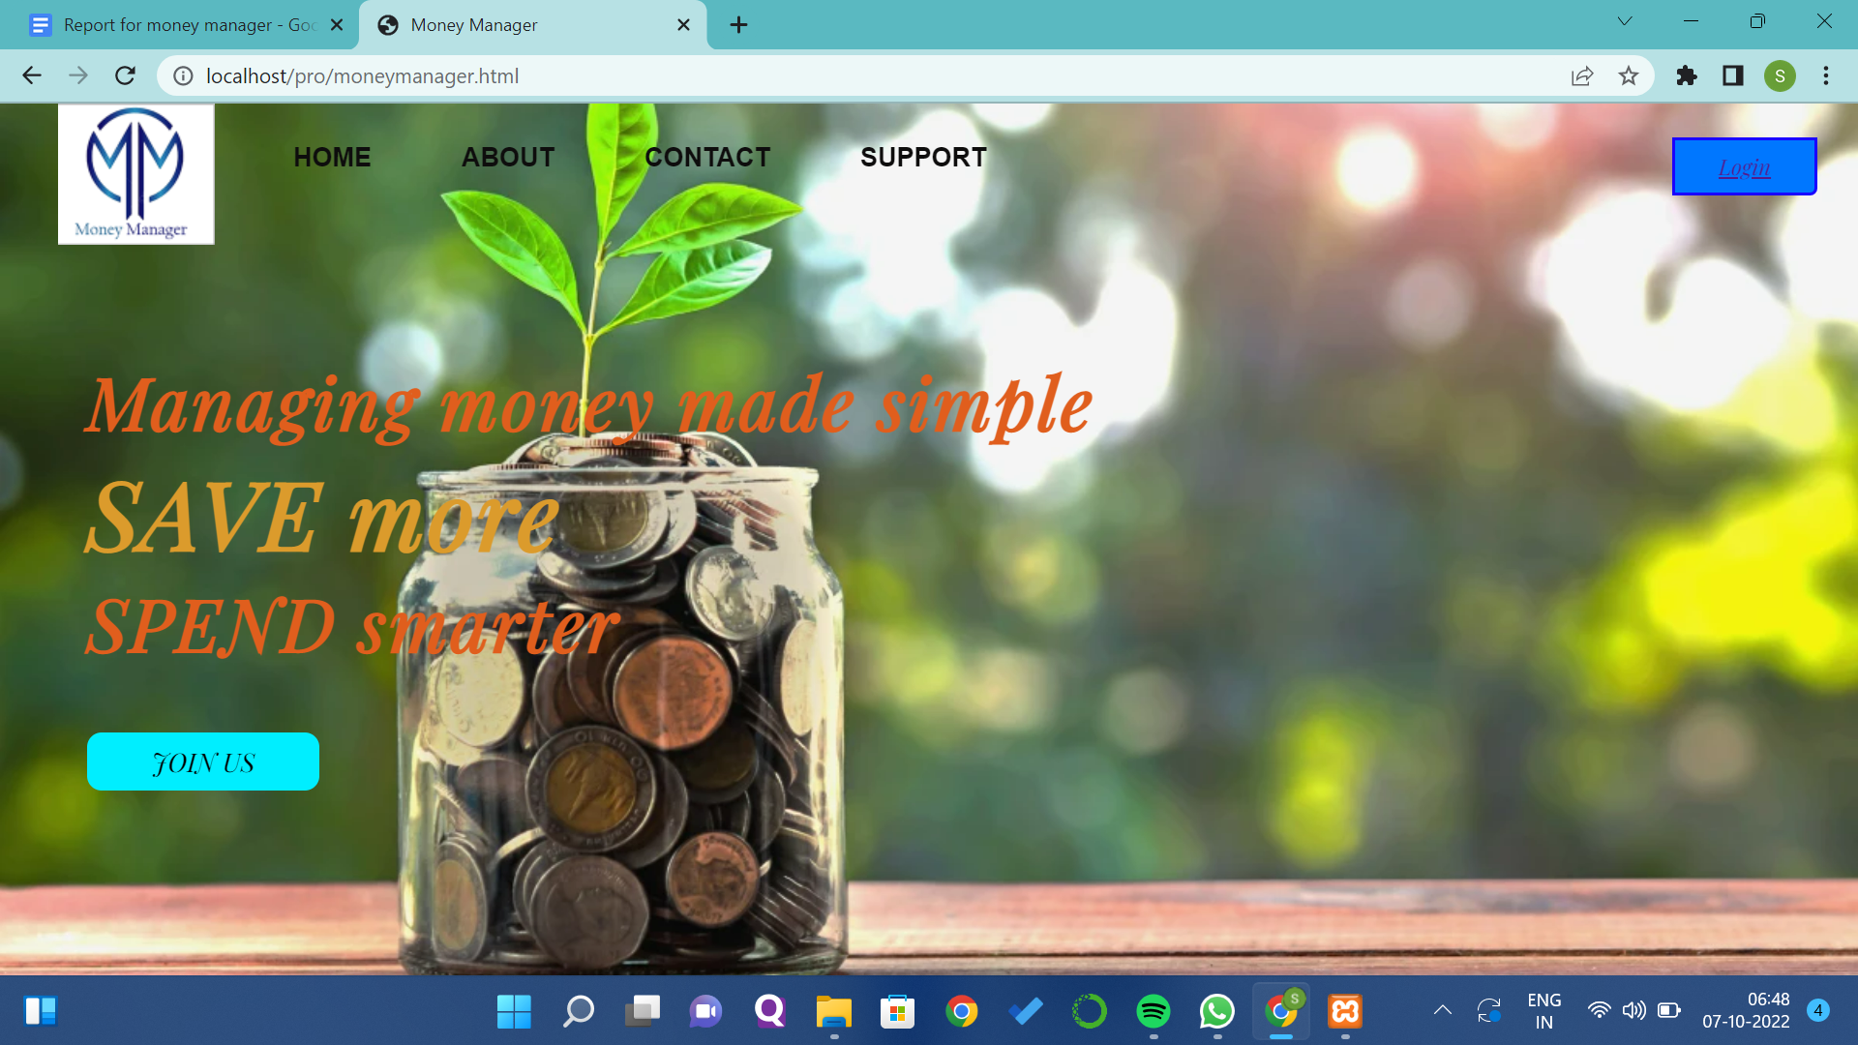

**About Us Page:**

**Contact Us Page:**

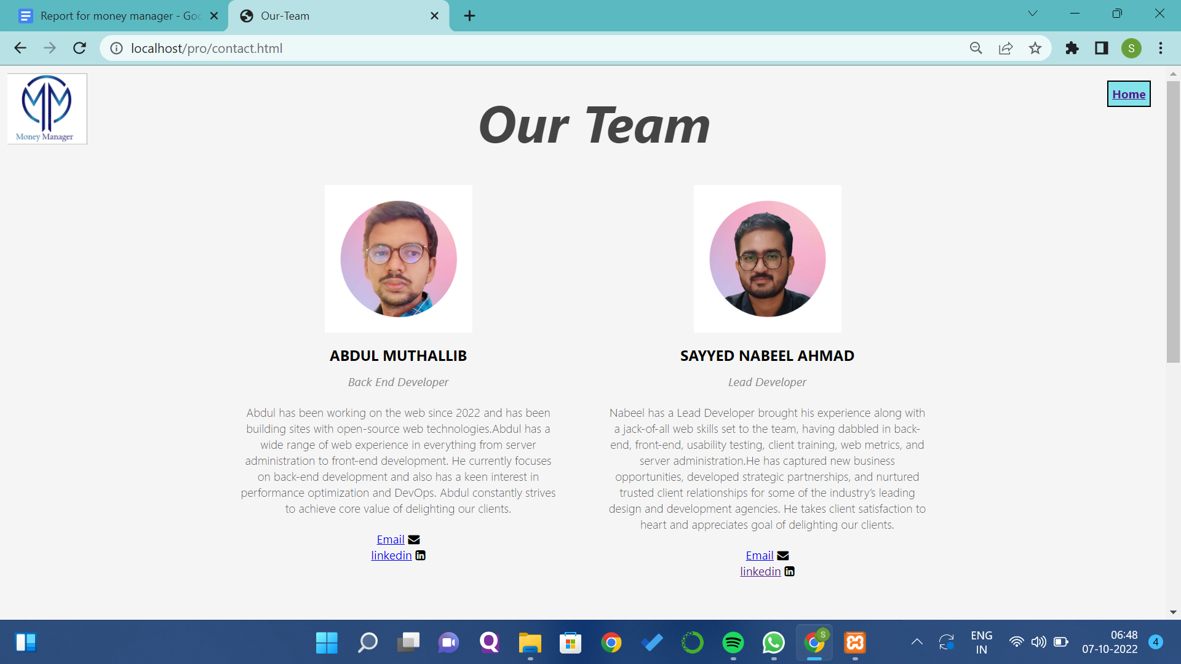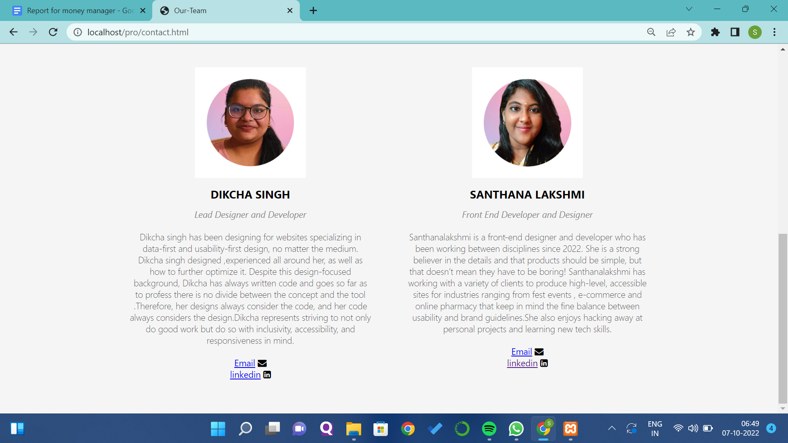

**Support Page:**

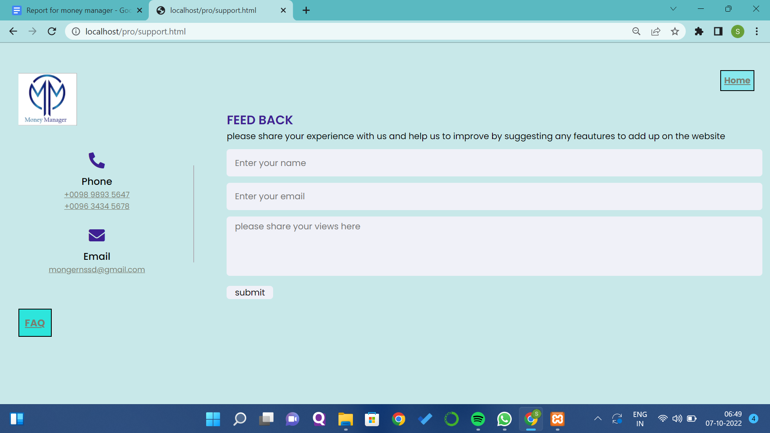

**FAQ Page:**

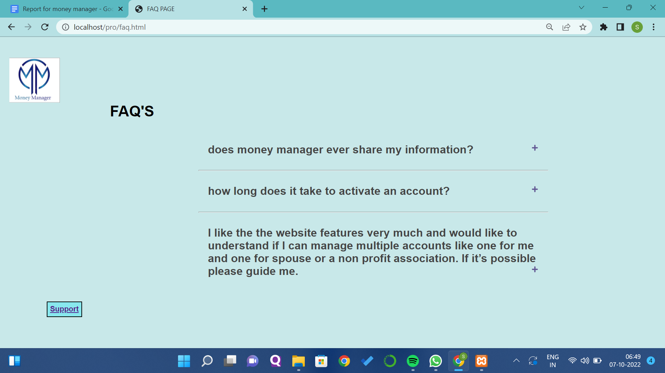

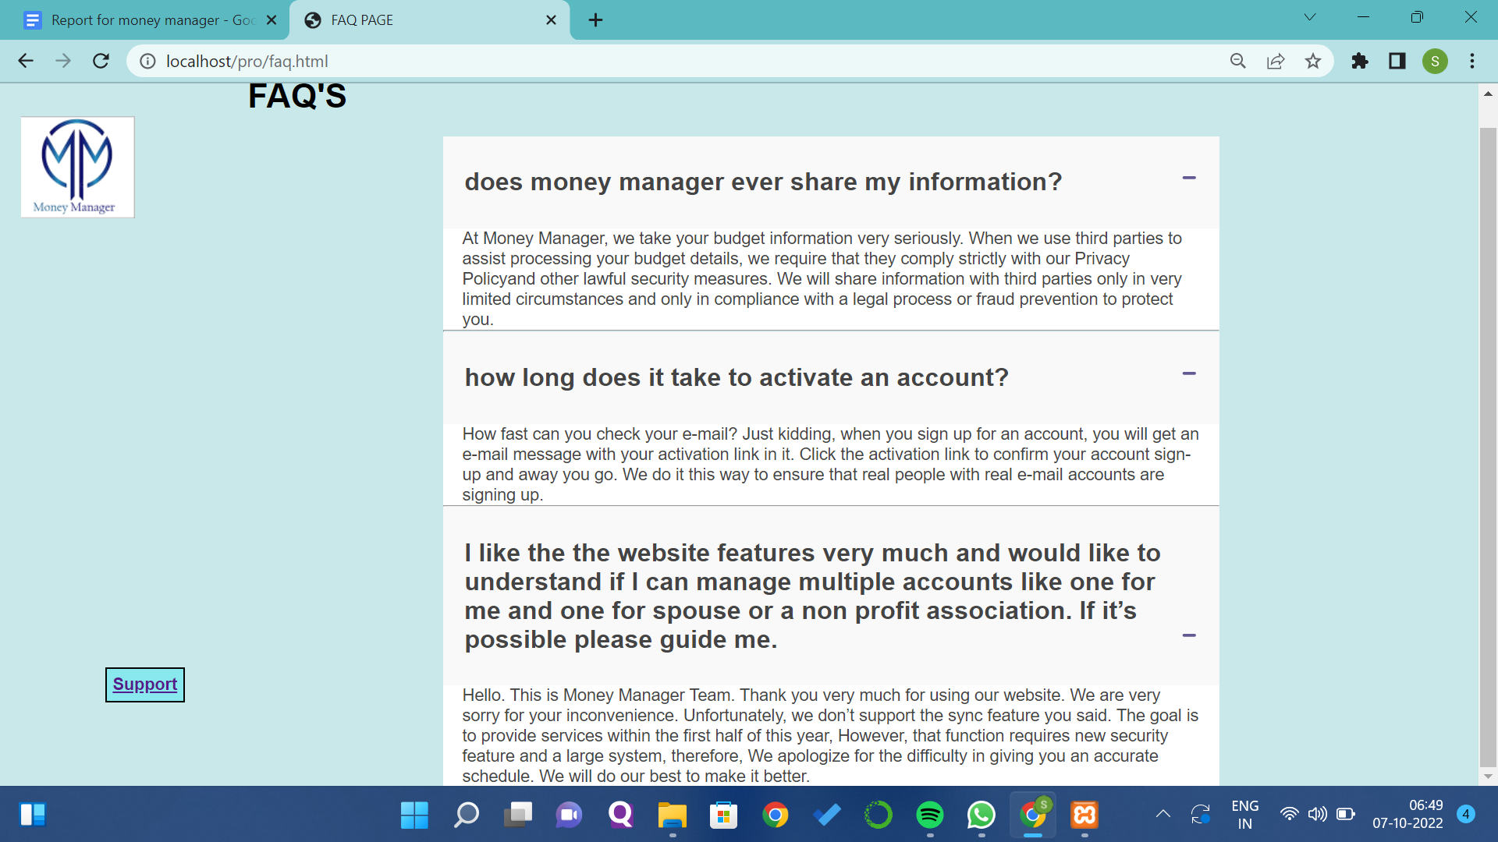

**Login Page:**

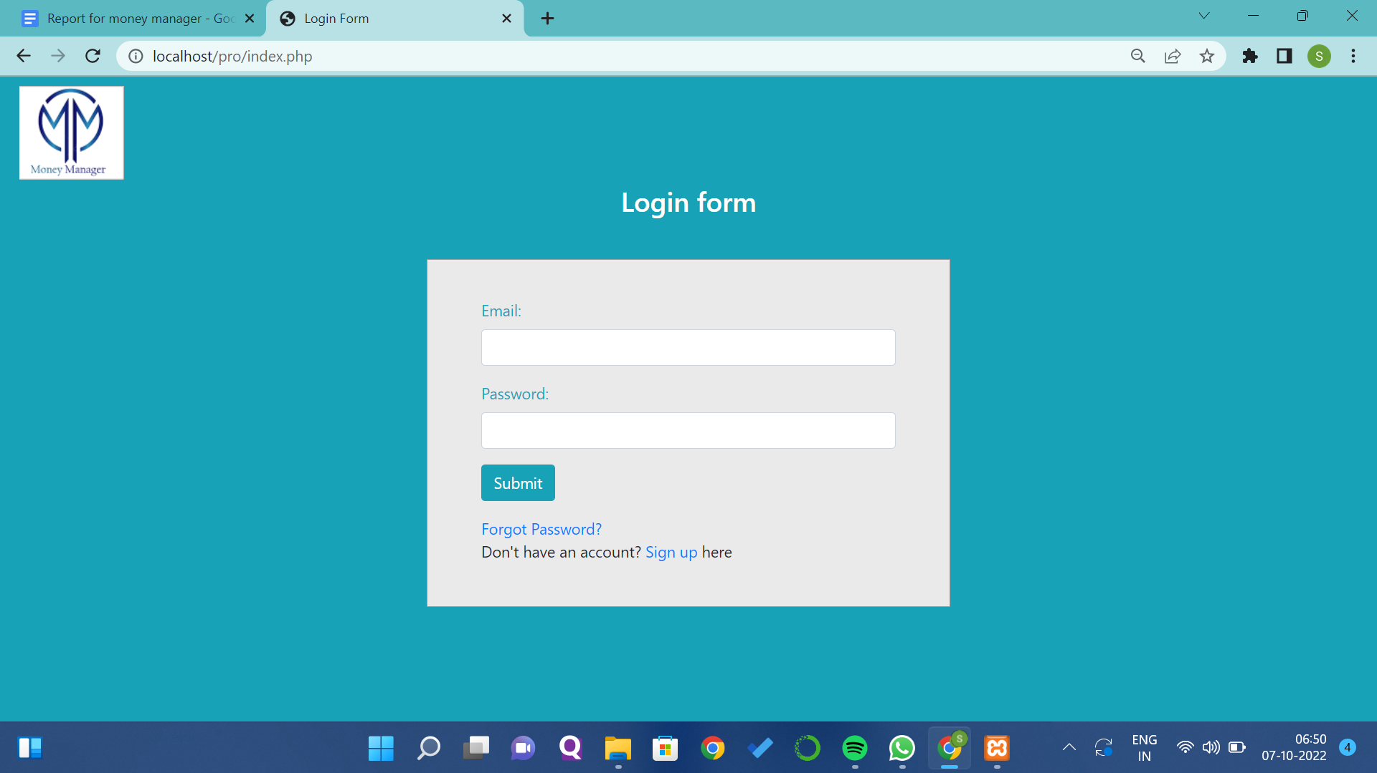

**Forget Password Page:**

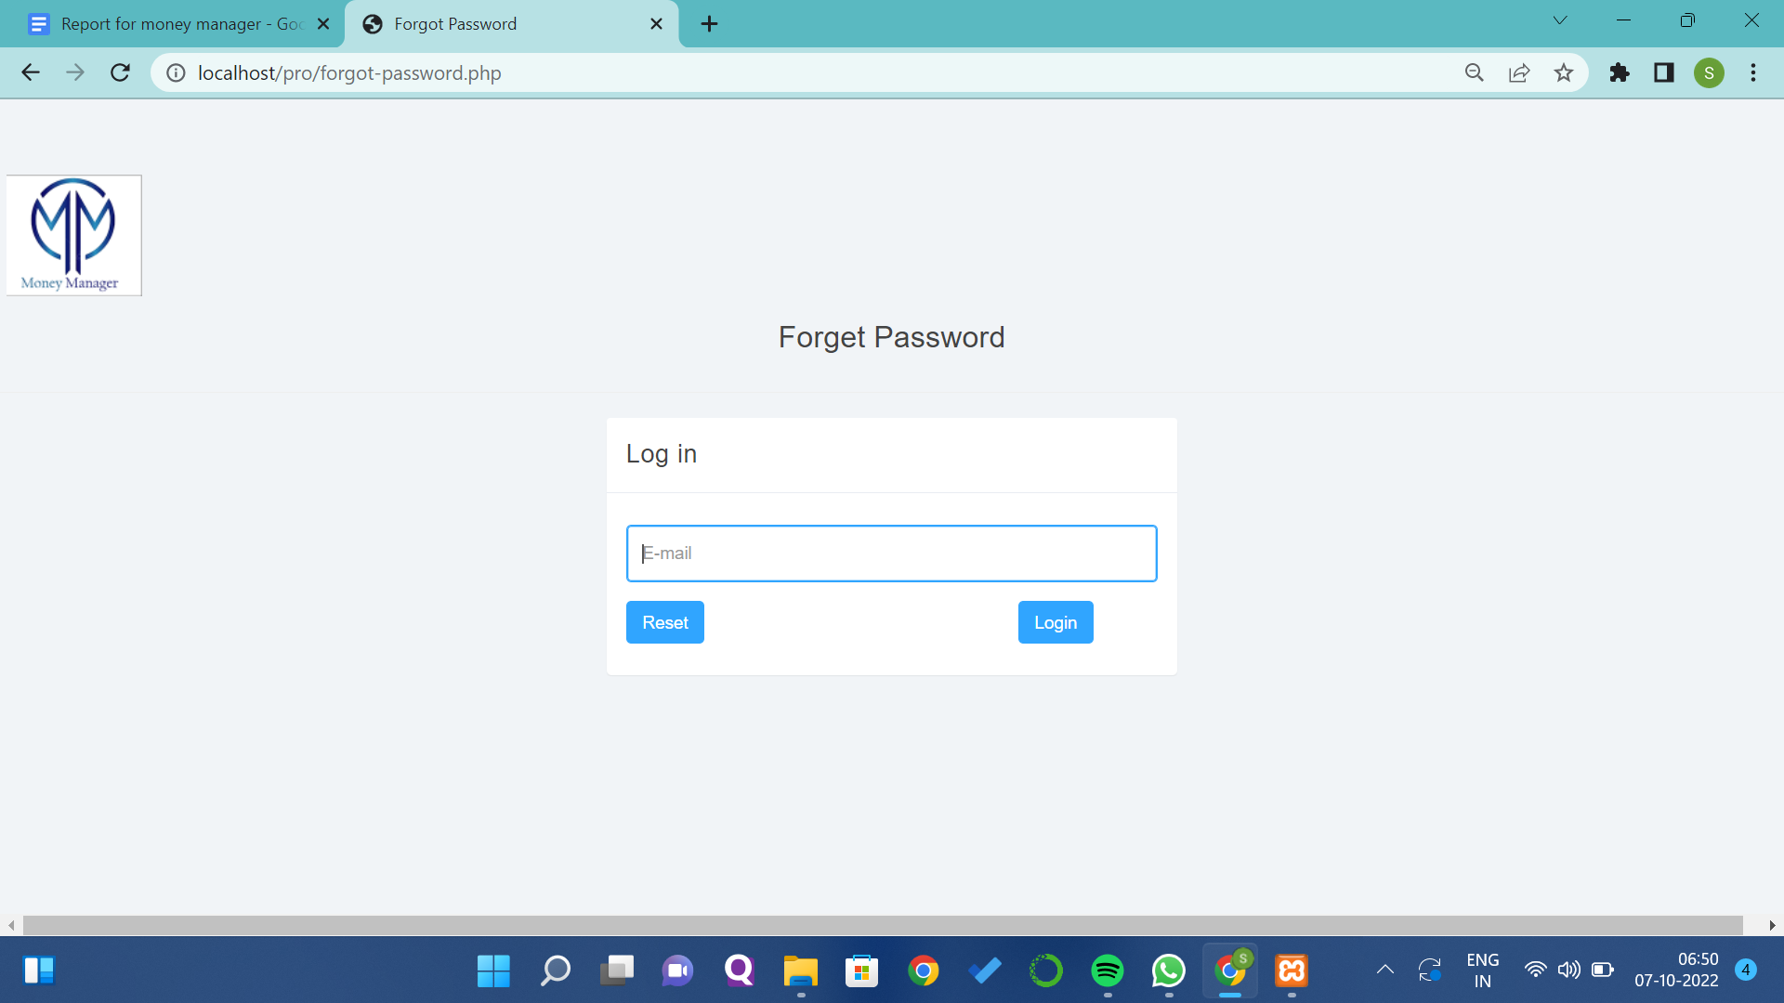

**Signup Page:**

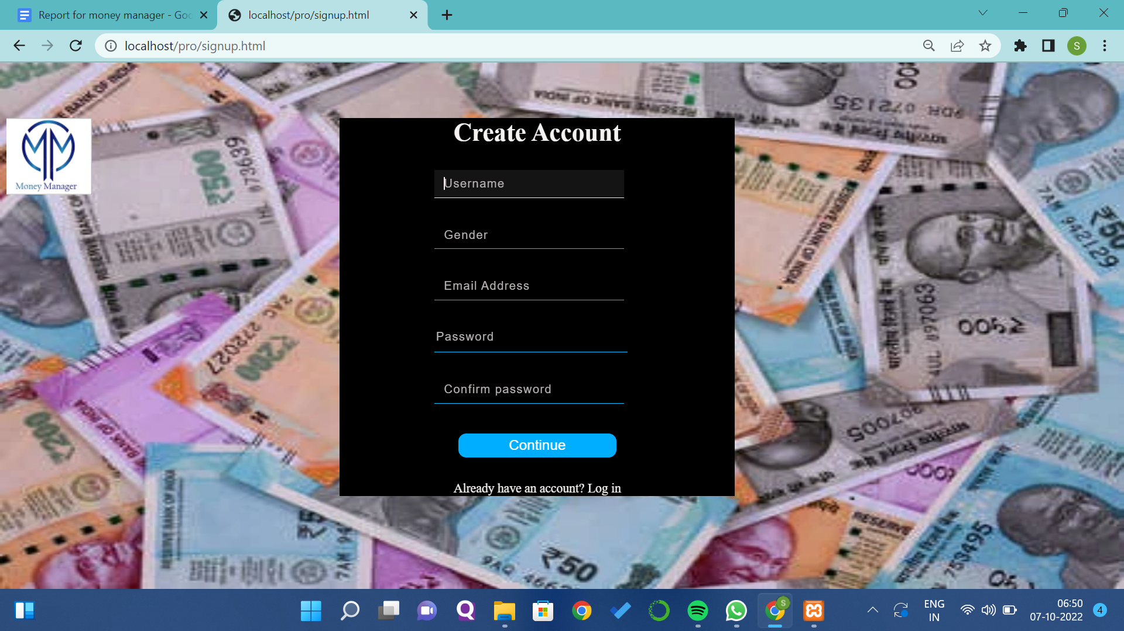

**Dashboard Page:**

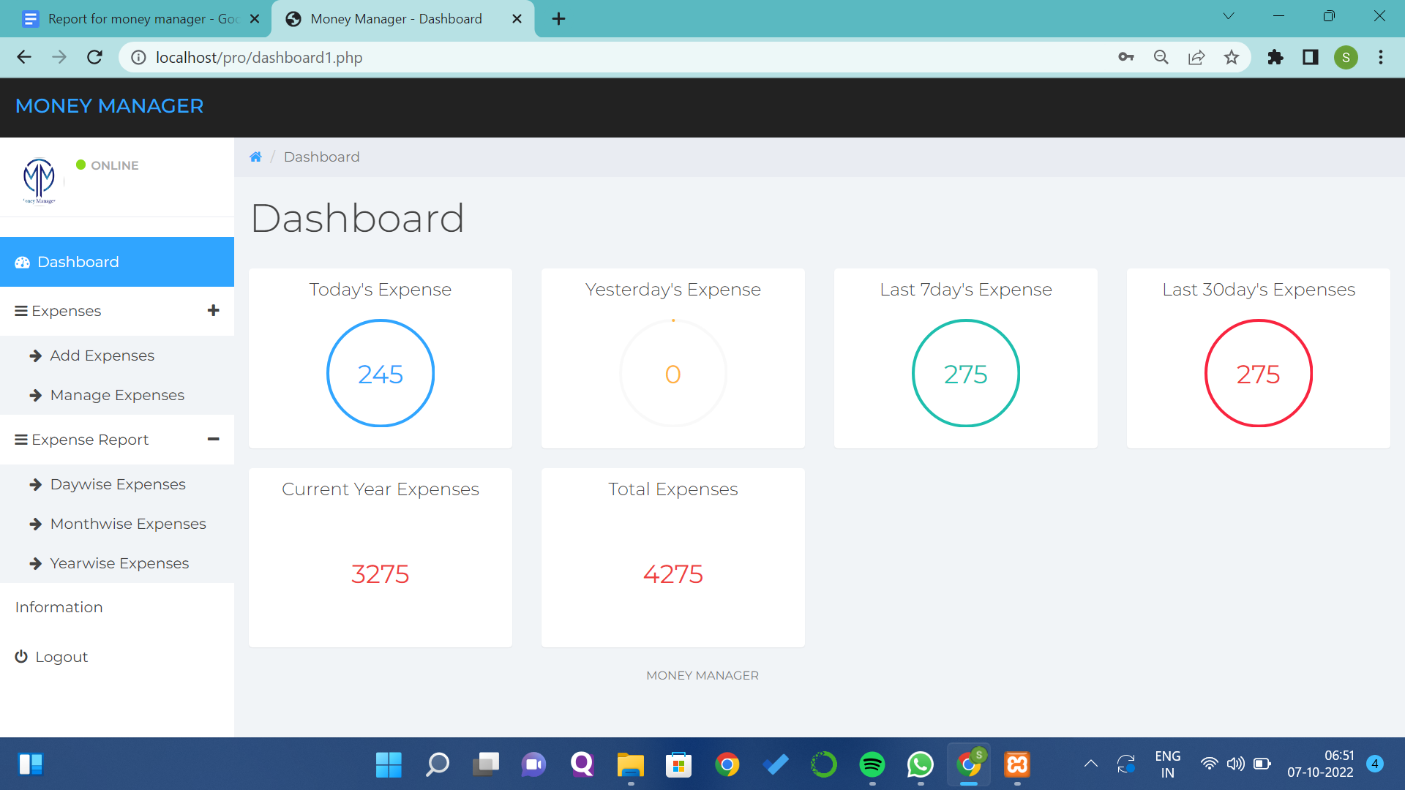

**Add Expenses Page:**

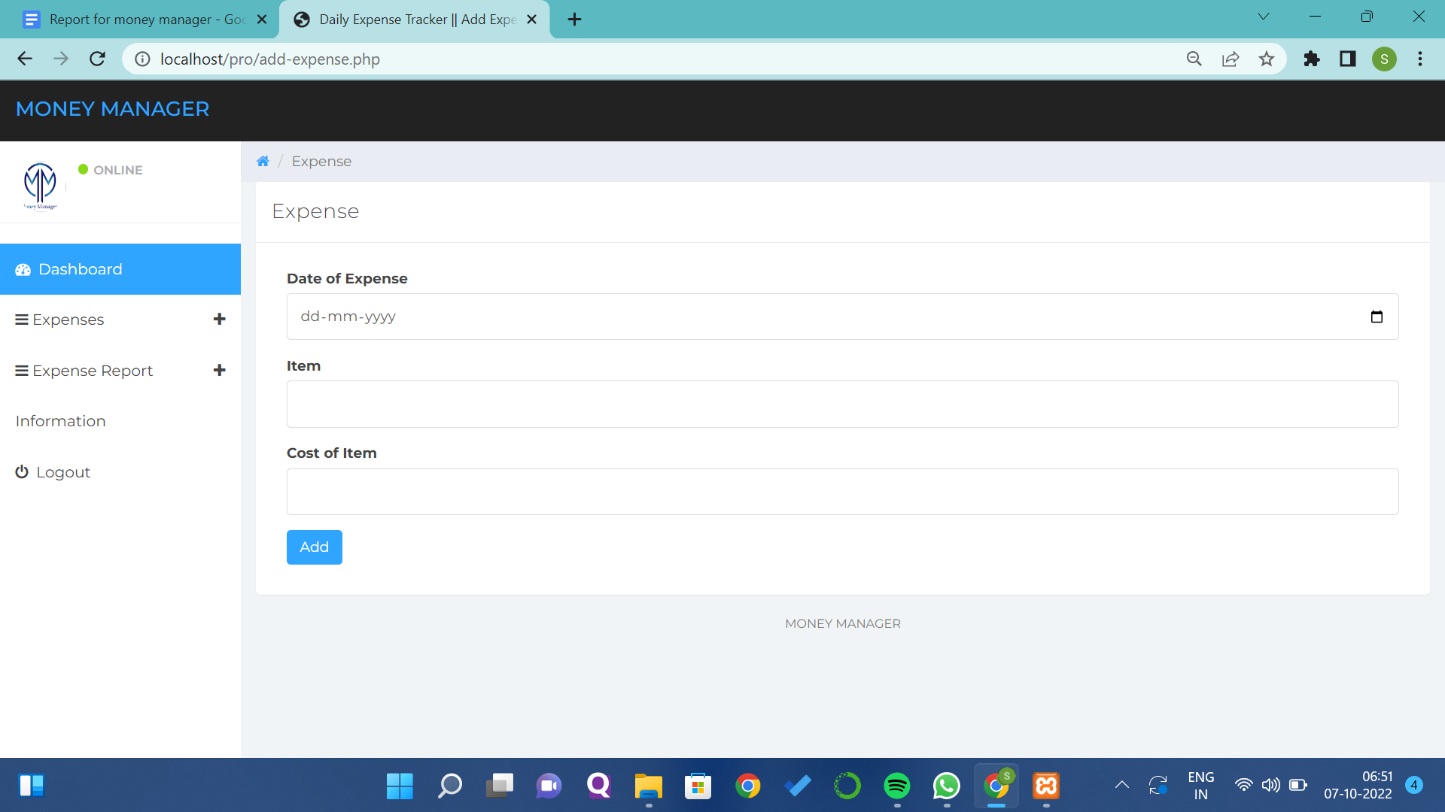

**Manage Expenses Page:**

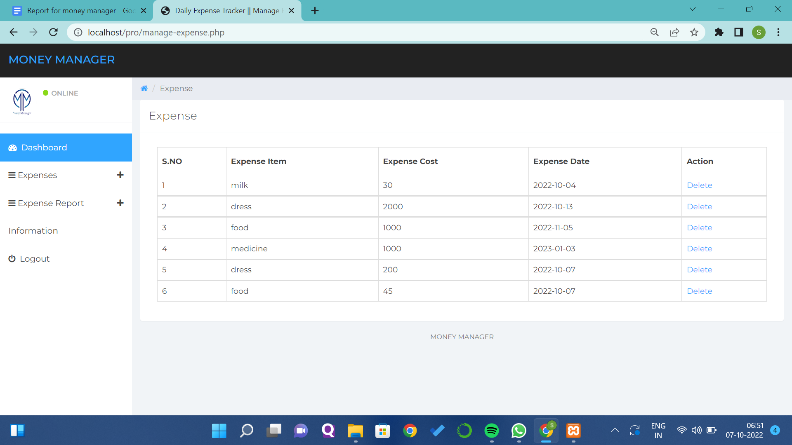

**Date wise Expenses Report:**

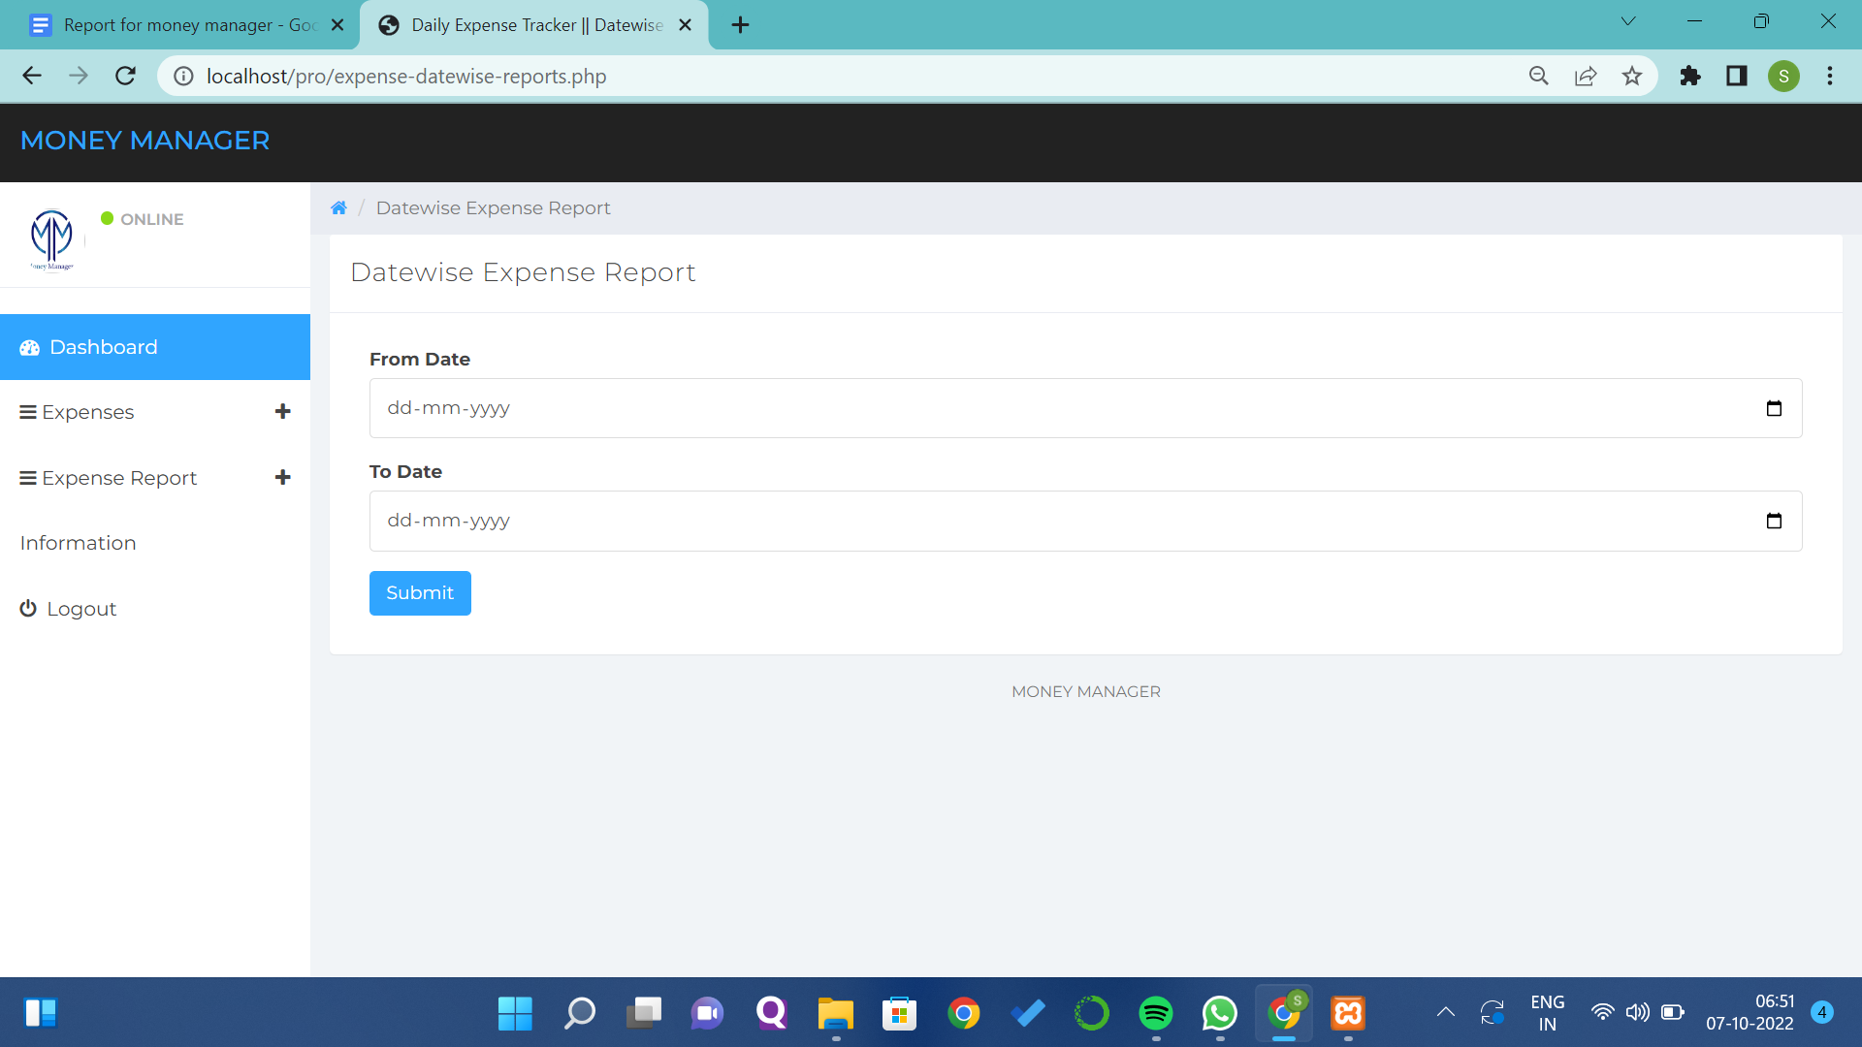

**Month Wise Expenses Report:**

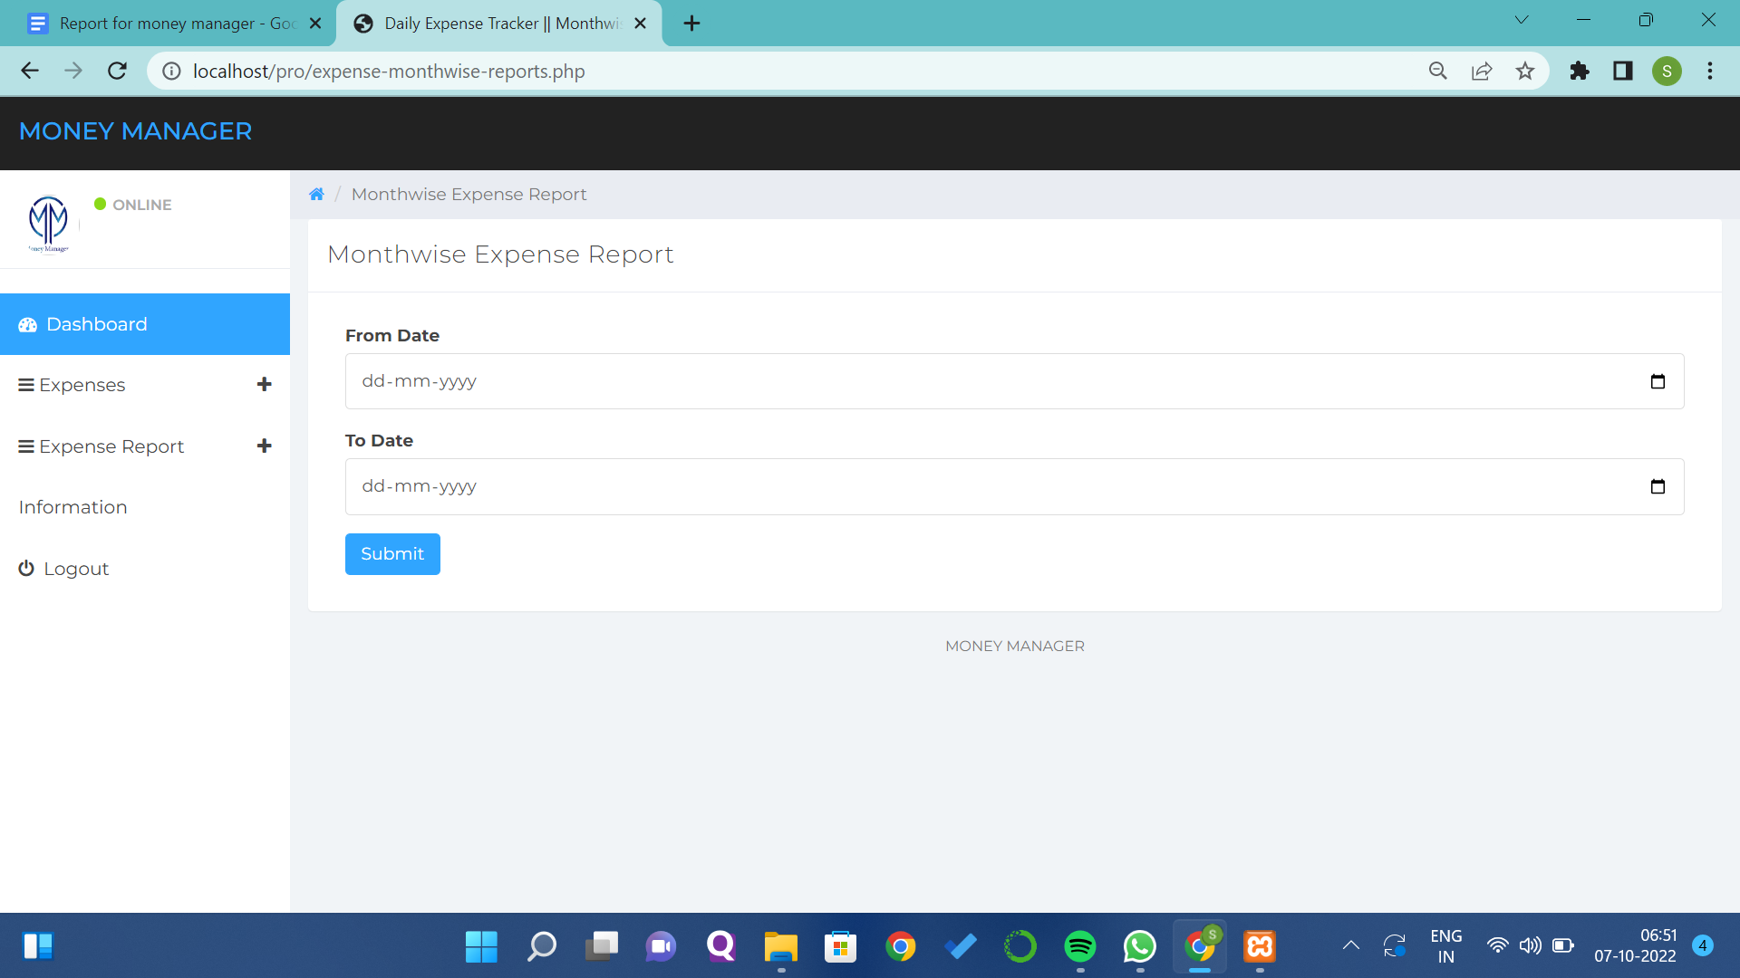

**Year Wise Expenses Report:**

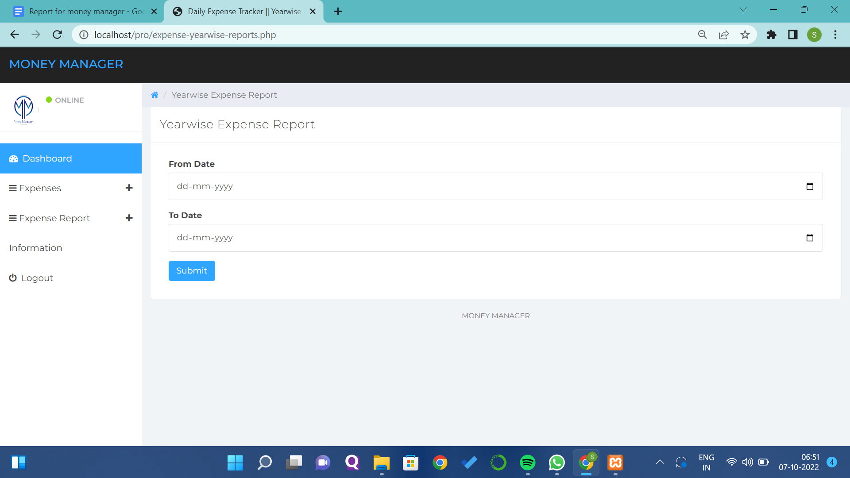

**Information Page:**

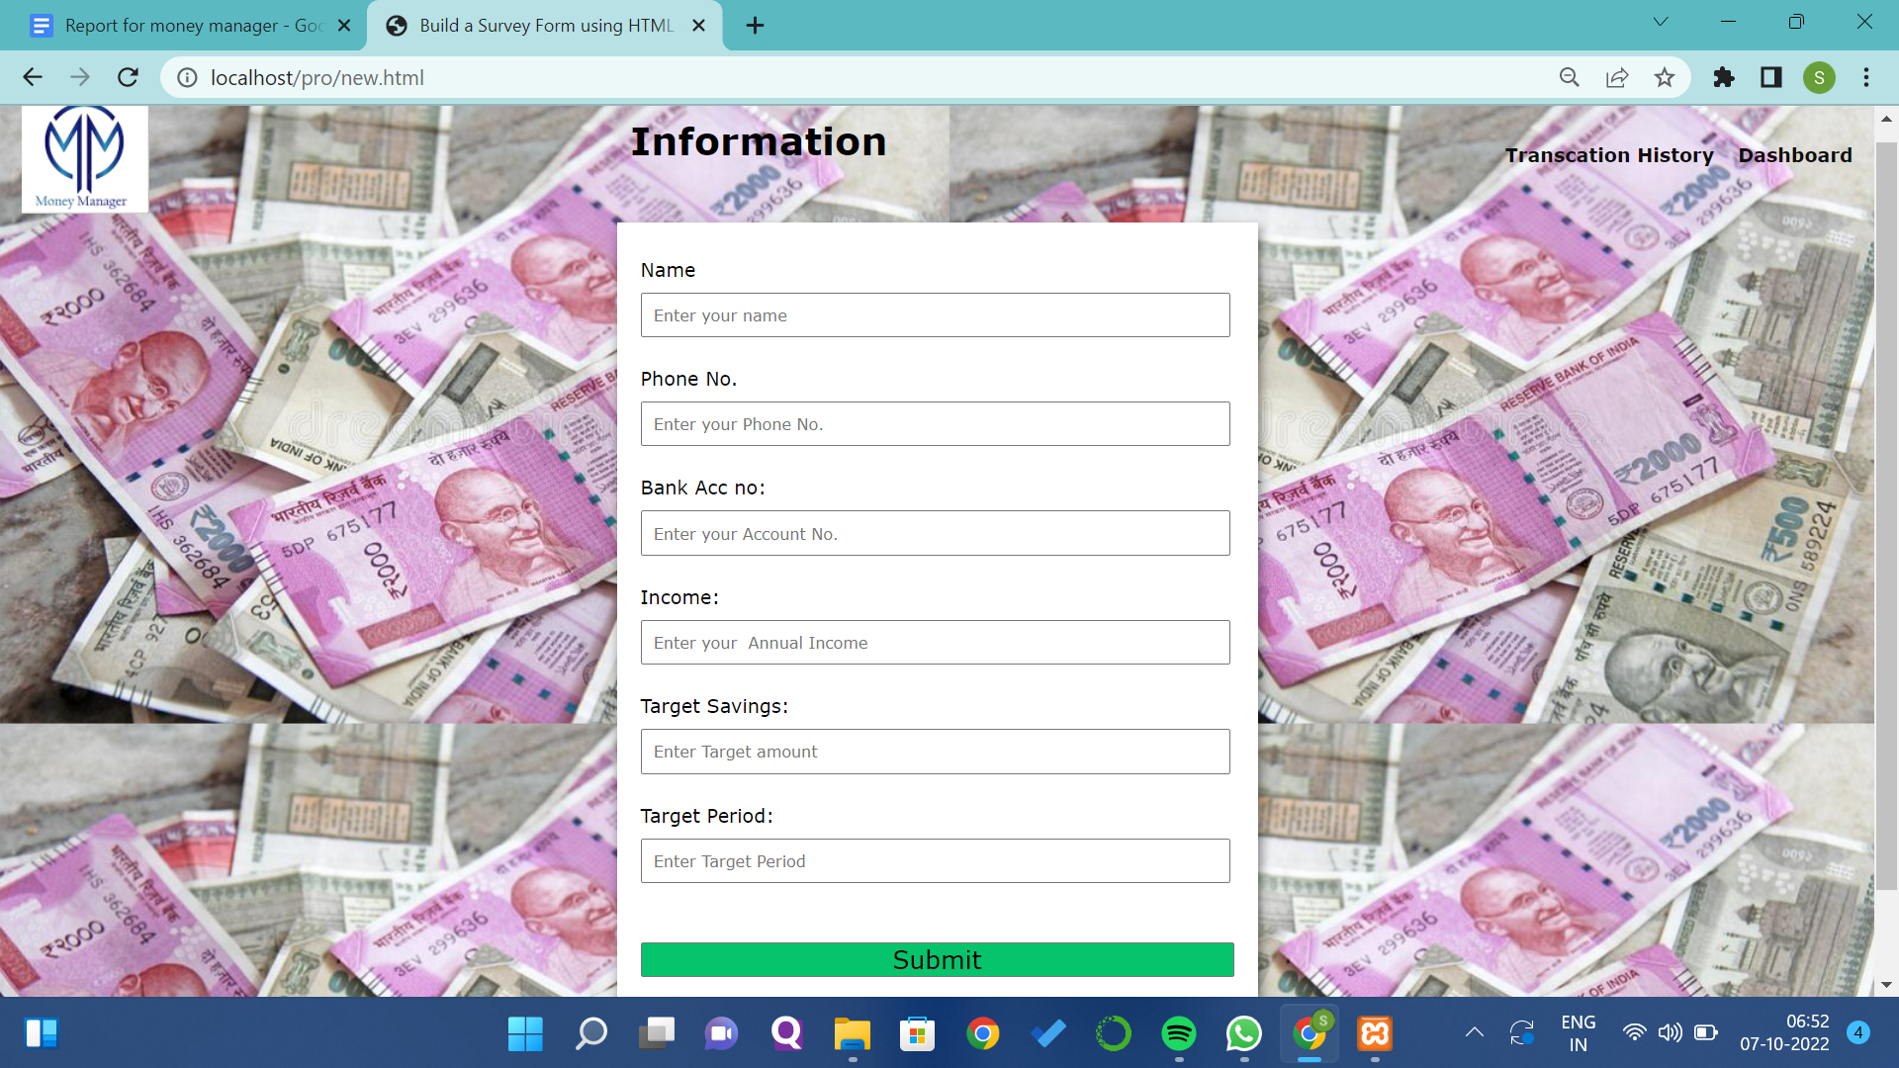

**Result Page:**



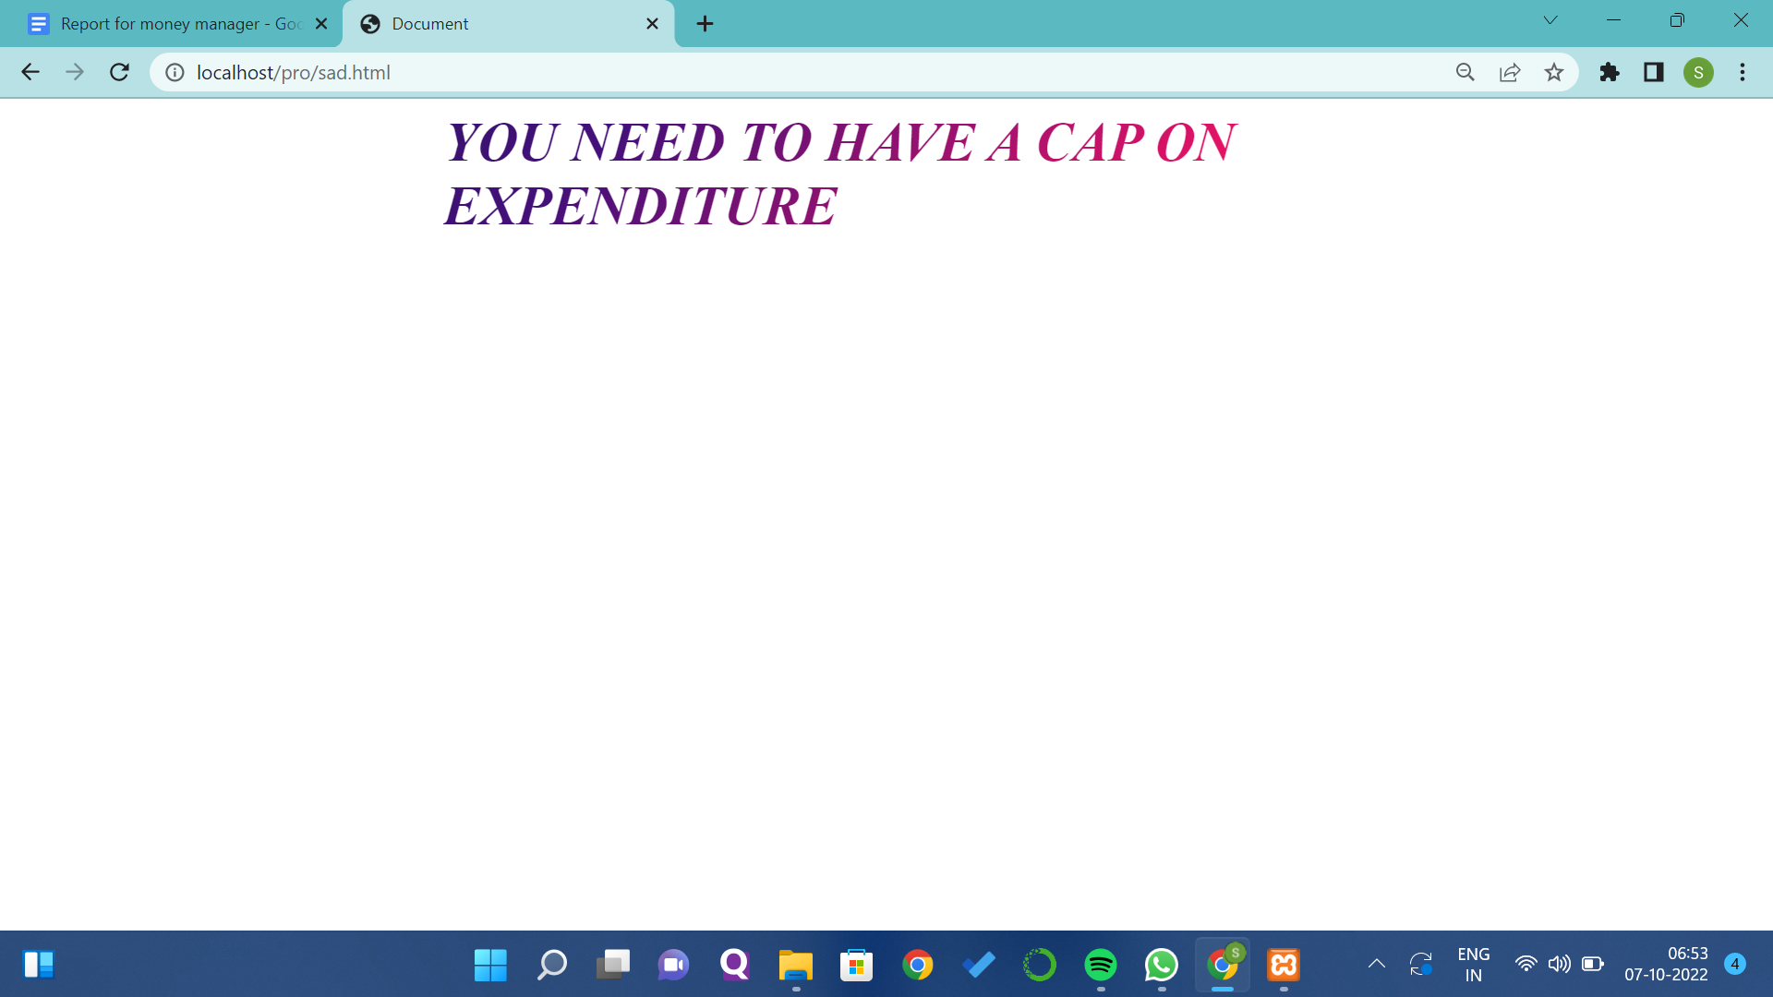

**Transaction History Page:**

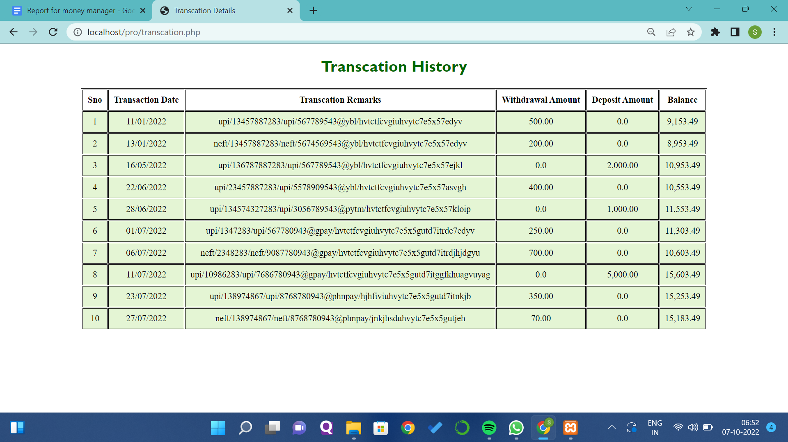

**Conclusion:**

We were successfully able to build a website which will be helpful for the general public who wants to keep an eye on their expenses and focus on their savings.

**Future:**

* Chat bot we will implement in our website for easy communication.
* Instead of manual entry we will try to get details by using the voice of the users.
* We will link the Users Bank Transaction Details.

**For Reference:-**

<https://www.slideshare.net/RashnaMaharjan2/daily-expense-tracker-153160282?from_action=save>